Mariia Ilina

Contact

E-mail [milina@g.emporia.edu](mailto:milina@g.emporia.edu)

Github: MariiaIlina1

Portfolio:

MS-Informatics Graduate

Professional Summary

As a highly motivated MS-Informatics graduate with a strong focus on data analytics and programming, I am excited to apply for the Data Analyst position in the Utility Programs and Services division. I have a solid understanding of data visualization techniques and tools, which allows me to communicate complex data findings effectively to both technical and non-technical audiences. My skills in managing databases, reporting and data analysis make me a perfect fit for this role, and I am eager to bring my expertise to the Mid-Atlantic Operations team.

Skills

Education

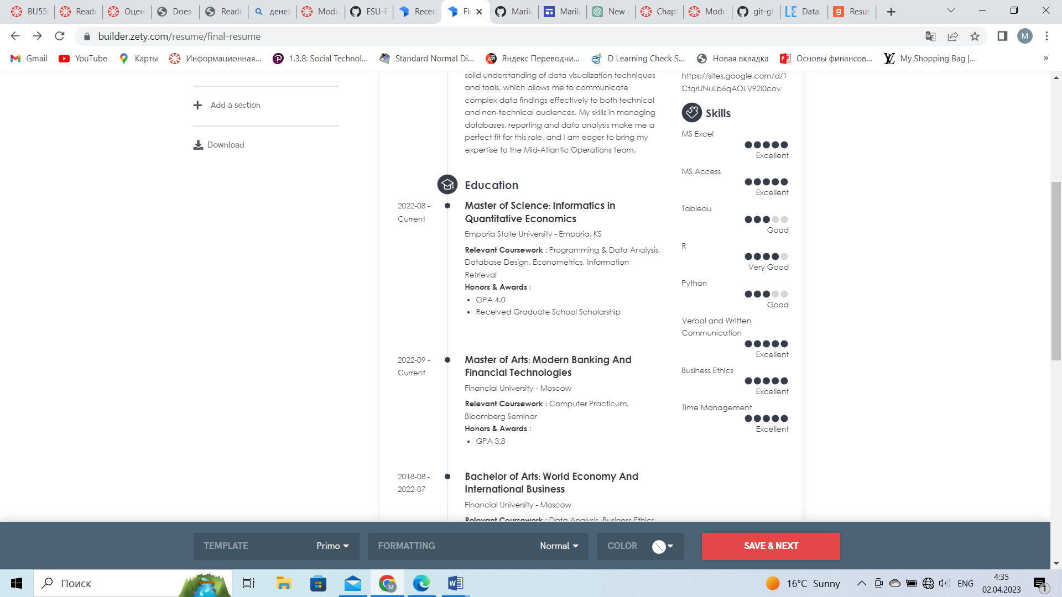**2022-08 - Current**

**Master of Science: Informatics in Quantitative Economics**

**Emporia State University - Emporia, KS**

Relevant Coursework : Programming & Data Analysis, Database Design, Econometrics, Information Retrieval

Honors & Awards : GPA 4.0

Received Graduate School Scholarship

**2022-09 - Current**

**Master of Arts: Modern Banking And Financial Technologies**

**Financial University - Moscow**

Relevant Coursework : Computer Practicum, Bloomberg Seminar

Honors & Awards : GPA 3.8

**2018-08 - 2022-07**

**Bachelor of Arts: World Economy And International Business**

**Financial University - Moscow**

Relevant Coursework : Data Analysis, Business Ethics, Financial Forecasting

Honors & Awards : GPA 4.0

Work History

**2022-08 - Current**

**Admissions Assistant**

**Emporia State University, Emporia, Kansas**

* Helped with interview process, orientation program and implementation of admissions policies as applications were considered and members selected.
* Assisted applicants with admissions packet and served as point of contact throughout admissions process.

**2022-02 - 2022-08**

**Audit & Tax Consultant**

**KPMG, Moscow**

* Kept up-to-date with tax changes and industry trends by participating in professional organizations, opportunities, and networks.
* Identified legal tax savings and recommended ways to improve profits.
* Collaborated with accounting manager to comply with governing bodies and limit regulatory risks.
* Partnered with auditors to track errors and add contributions to maintain accuracy.

**2021-01 - 2022-03**

**Finance Consultant**

**Ernst & Young, Moscow**

* Developed various business models to forecast operating expenses and revenue based on market conditions.
* Produced monthly, quarterly and annual analysis, statistics and metrics.

Languages

Accomplishments

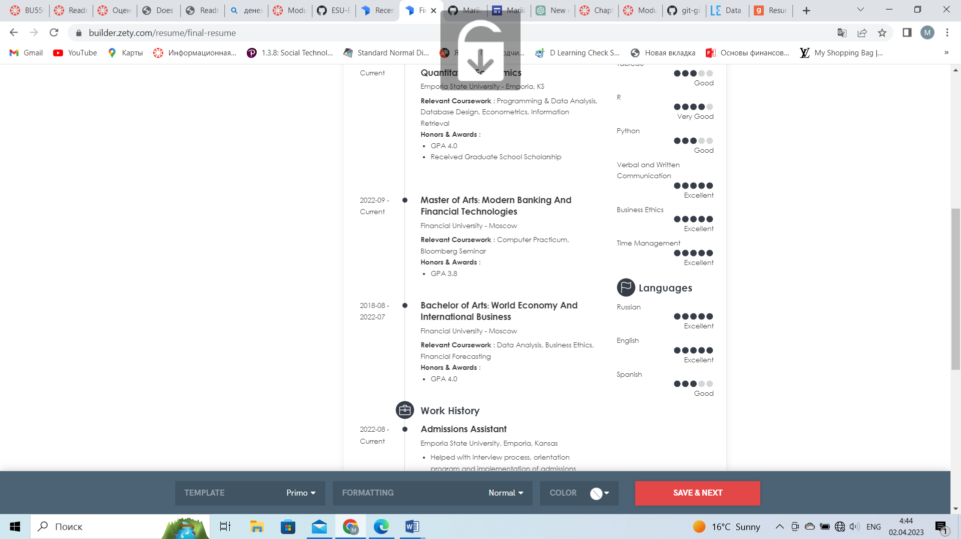

**Research Project on the Competition Level in Banking Sector for Russian Banks Association**